PRESS RELEASE

EeMAP Consortium welcomes E.ON’s consumer research

Brussels, 15 February 2018 – For immediate release

Consumer research led by E.ON indicates that Energy Efficient Mortgages could be the answer customers have been looking for.

Access to affordable finance has long since been an obstacle for many customers thinking about an energy efficient makeover for their home. The Energy efficient Mortgage Action Plan (EeMAP) project aims to create a standardised “energy efficient mortgage”, providing building owners with the incentives to improve the energy efficiency of their homes or business buildings, or to acquire an already energy efficient property through preferential financing conditions linked to the mortgage.

Today research led by our consortium partner E.ON, reveals the answer to the question of whether customers actually would take up such a product. Consumer studies across Germany, Italy, Sweden and the United Kingdom found a positive customer reaction to the concept of an energy efficient mortgage.

In Italy 80% of people found the idea very or quite appealing, followed by the UK with 66%, with very low outright rejection of the idea. Not surprisingly, the appeal is highest to those customers who are open to making energy efficiency improvements to their properties and to those that would consider taking out a loan to do so.

The one most important reason for finding the product appealing (excluding those that found it unappealing) was the financial benefits. Financing means different things in the study countries, in the UK and Sweden it is about having access to a lower interest rate, while in Italy it is about achieving long term savings. Of almost equal importance to finance as a driver are energy considerations, specifically benefiting from lower energy bills in the long term, particularly in the UK and Italy. The emotional benefit of achieving a warm and comfortable home was also a strongly recognised energy benefit in all countries.

Marco Marijewycz, Market Manager at E.ON Solutions and EeMAP consortium member, who led consumer research, said:
“Our study shows that customers see the benefits of an energy efficiency mortgage as delivering a triple win: lower energy bills, lower mortgage rates and a warm, more comfortable home. This product could also open up new innovative partnerships between lenders and utilities”.

Luca Bertalot, EeMAP Coordinator & EMF-ECBC Secretary General, said: “Key to the success of the Energy Efficient Mortgage Initiative is robust consumer demand. The consumer research published today is not only encouraging because of the positive consumer feedback, but it will be invaluable in guiding the preparations for the forthcoming EeMAP pilot phase and in helping banks to understand what consumers do and don’t want so that they can design a future energy efficient mortgage product that responds to the needs of the market.”

The pilot phase of EeMAP will commence on 14 June 2018. The objective of the pilot scheme is to test the energy efficient mortgage product blueprint at national level with key stakeholders such as banks, property valuers, Green Building Councils and energy utilities. The pilot phase will be underpinned by a standardised framework consisting of high-level guidelines, which went into market consultation earlier this week. A large group of pioneer lenders, including major banks, medium size players and local, specialised lenders in Europe have already signalled their interest in being involved in the pilot.

The consumer research report led by E.ON is available on the EeMAP website.

Notes to Editors

The EeMAP Initiative - led by the European Mortgage Federation-European Covered Bond Council, Ca’ Foscari University of Venice, RICS, the Europe Regional Network of the World Green Building Council, E.ON and SAFE Goethe University Frankfurt aims to create an energy efficient mortgage through which homebuyers are incentivised to improve the energy efficiency of their building or acquire an already energy efficient property by way of favourable conditions liked to the mortgage. The cornerstone of the initiative is the assumption that energy efficiency has a risk mitigation effect for banks as a result of the impact on a borrower’s ability to service his/her loan and on the value of the property, a correlation which the EeMAP Initiative will seek to substantiate.

For more information about the EeMAP Initiative, please visit the EeMAP website: www.energyefficientmortgages.eu

For more information about the Pilot Phase Guidelines and the market consultation, please visit: http://energyefficientmortgages.eu/wp-content/uploads/2018/02/EeMAP-Energy-Efficiency-Mortgage-Pilot-Scheme-Implementation-Guidelines-Draft-for-Consultation.pdf

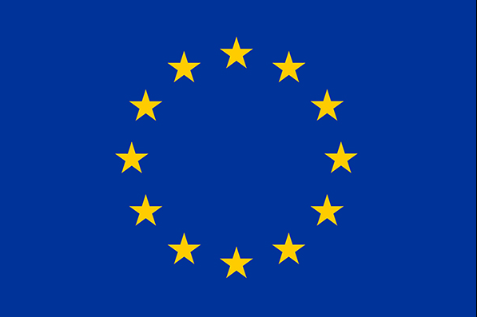

This project has received funding from the European Union’s Horizon 2020 research and innovation programme under grant agreement No 746205. The sole responsibility for the content of this material lies with the authors. It does not necessarily represent the views of the European Union, and neither EASME nor the European Commission are responsible for any use of this material.

